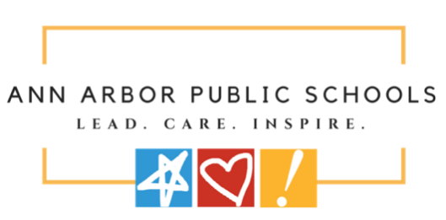
ANN ARBOR PUBLIC SCHOOLS
ADVERTISEMENT FOR BIDS

Sealed bids for the Ann Arbor Public Schools, New Dicken Elementary School Phase 2 – AV Rebid Project prepared by DLR Group and Wightman, located at 2135 Runnymede Boulevard, Ann Arbor, MI 48103 (IFB No. 25.0026 A) will be received through Building Connected by 2:00 PM on May 28th, 2026.

BIDS:
This Bid will consist of separate sealed bids for the following Sites:

AAPS – New Dicken Elementary School - Phase 2 – 2135 Runnymede Blvd, Ann Arbor, MI 48103

SUBMISSION REQUIREMENTS:
Completed Bids shall be submitted electronically through BuildingConnected:
https://app.buildingconnected.com/public/58a356fbffd85f0b005a722e
Ann Arbor Public Schools – New Dicken Elementary - Phase 2 AV Rebid

Step-by-step instruction for submitting a bid on BuildingConnected can be found at the following link: https://buildingconnected.zendesk.com/hc/en-us/articles/360010222793-How-to-submit-yourbid-through-BuildingConnected

Bids submitted after the time and date posted above will not be opened or accepted. Faxed and/or E-mail proposals will not be opened or accepted.

Electronically Submitted Bids will be publicly opened at approximately 2:30 PM on May 28th, 2026. The Bid Opening will be publicly conducted via a Zoom meeting. Information regarding joining the Zoom meeting is as follows:

When: May 28, 2026 02:30 PM Eastern Time (US and Canada)
Topic: 25.0026 New Dicken Elementary School Phase 2 - AV Rebid Opening

Join from PC, Mac, iPad, or Android:
https://us02web.zoom.us/j/84802285461
Phone one-tap:
+13126266799,,84802285461# US (Chicago)
+16465588656,,84802285461# US (New York)

Webinar ID: 848 0228 5461

Bidding Documents will be available by 4:00 PM on May 4th, 2026, via Building Connected.
Bidding documents will be available for public inspection at BuildingConnected.com
All questions must be directed via BuildingConnected.
PRE-BID MEETING:

The Pre-Bid meeting is not mandatory; however, bidders are strongly encouraged to attend.
An online pre-bid meeting will be held May 12th, 2026, at 2:00 PM via Zoom.

Please click the link below to join the webinar:
When: May 12, 2026 02:00 PM Eastern Time (US and Canada)
Topic: 25.0026 A New Dicken Elementary School Phase 2 - AV Rebid

Join from PC, Mac, iPad, or Android:
https://us02web.zoom.us/j/81109881635

Phone one-tap:
+13052241968,,81109881635# US
+13092053325,,81109881635# US

Webinar ID: 811 0988 1635

BID PARTICULARS:
All bids must include the following:

- Bid Security of 5% for bids of $50,000.00 or higher.
- Bid Pricing Form (required or disqualified)
- Familial Disclosure Statement (required or disqualified)
- Contractor Information Form
- Iran Economic Sanctions Act Form
- Certification Form

Bids must be accompanied by a Bid Security, in either the form of a bid bond or certified bank check, in the amount of five (5) percent of the amount of the Bid, payable to Ann Arbor Public Schools, as a guarantee that if the Bid is accepted, the School District is secured from loss or damage by reason of the withdrawal of the Bid or failure of the Bidder to enter a Contract for performance, Further, the Bidder will execute the contract, provide the required insurance certificate(s) and file the required bonds within (10) days after notice of award of Contract but prior to Work commencing.
The successful Bidder may also be required to furnish a Performance Bond and Labor and Material Payment Bond in the amount of 100% of the contract price.
Ann Arbor Public Schools reserves the right to reject any or all bids received, to waive any informalities and irregularities in the bidding, and to accept a bid other than the lowest bid.

END OF ADVERTISEMENT FOR BID

